# **TRUSTEE ROLES**

# **AT**

# **(BRITISH SOCIETY OF HAEMATOLOGY)**

Welcome 2

Role Descriptions 3

Person Specification 6

Commitment to equality, diversity and inclusion 7

Additional information 7

# Welcome

Dear Candidate,

Thank you for considering joining the British Society for Haematology (BSH) and helping to shape our future.

BSH, founded in 1960, is a charity and membership body for professionals

working in the field of blood disorders. In 2020 we celebrated our 60th anniversary and you can find out more about our history and that of haematology on our website: <https://b-s-h.org.uk/bsh-at-60/>

BSH’s charitable objectives are to advance the practice and study of haematology,

and to facilitate contact between persons interested in haematology.

The Society is led by a volunteer board of 14 which consists mainly of trustees

elected by the membership. The Society has a small, dedicated staff team of 14 FTE.

The Society has more than 2,800 members, the vast majority of whom are consultant and trainee haematologists based in the UK. In 2019 we introduced a new free Associate membership aimed at nurses, medical students, allied health

professionals, and doctors and scientists at the start of their career. This has

increased and diversified the Society’s membership across today’s multi-

disciplinary team.

**The Society’s main areas of activity are:**

* Clinical guidelines across all aspects of the specialty
* Annual Scientific Meeting, which attracts 1400+ delegates
* E-learning educational work, which is mainly aimed at trainees, junior doctors and undergraduate *British Journal of Haematology (BJHaem)* and the open access publication *eJHaem*;
* Grants and awards programme
* Small events programme.

We are currently seeking 2 new Lay Trustees having first recruited Lay Board members in 2016 and 2 BSH Enterprises Board Directors (our trading subsidiary). More details about the roles and the skills we are seeking are included on the

following pages.

Thank you for your interest and we look forward to receiving your application.

Yours faithfully

Dr Josh Wright, President and Board Chair

Dr Jim Seale, Board Secretary and Chair of the Nominations, Governance and Awards Committee

Mr Keith Ward, BSHE Board Chair and Lay Trustee

# **Role Description - Lay Trustee x 2**

The Society’s Articles permit it to have four lay trustees on the Trustee Board at any one time. The Society recruited two lay trustees for

the first time in April 2016 and two more in June 2020; our first two lay trustees have now both left the Board. Each lay trustee has brought new skills and energy to the Trustee Board. In order to ensure we don’t lose all our lay trustees at the same time and to have a good mix of skills on the Trustee Board, the Society is now looking to recruit two more Lay Trustees who will serve an initial three-year term from April 2023, overlapping with our present two Lay Trustees.

BSH is seeking candidates with expertise in one or more areas of:

* Governance and strategy;
* HR;
* EDI and
* Sustainability.

It would be a bonus if they had prior experience of membership bodies and

experience at Board level in a substantial organisation.

The Trustee Board is strategic and ambassadorial with the day to day running

of the organisation being handled by the CEO. The trustees are accountable to the President, who is Chair of the Trustee Board and are required to have an Understanding and acceptance of the legal duties, responsibilities and liabilities of trusteeship and an understanding of the

respective roles of the Chair, Trustees and Chief Executive.

## Role Description - BSH Enterprises Board Directors x 2

BSH has a trading subsidiary, BSH Enterprises Ltd (BSHE). We run our Annual Scientific Meeting through BSHE. This is our flagship educational event and we wish to recruit two external Directors to the BSHE Board to widen the skill-sets on the Board.

The 2023 Annual Scientific Meeting Sessions include:

* Plenary sessions with UK and international partners
* Up to 5 parallel sessions over three days
* Clinical education sessions covering all aspects of the speciality
* Presenting the latest, cutting-edge research
* Oral free communications and poster session
* Substantial industry exhibition and sponsored symposia

We are particularly looking for candidates with experience in one or more of these areas:

Conference management Biomedical industry

Finance and business.

# **Person Specification (all roles)**

In addition to the specific skills requirements for each role listed above the following person specification criteria apply across all roles:

A proven ability to work effectively as a member of a team while contributing an independent perspective The ability to think strategically and challenge with good intent;

A commitment to BSH’s charitable aims;

An understanding of, and committment to, the values of accountability, probity and openness;

A proven track record of being able to process detail and get to the heart of an issue;

The ability to ask probing questions in a constructive way;

Ability to promote effective working relationships among Board Members and with BSH management;

Undisputed personal integrity and personal credibility;

A willingness to devote the time and effort required to effectively discharge the duties of this role;

Confident and effective in an ambassadorial and advocate role for the charity

## **COMMITTMENT TO EQUALITY, DIVERSITY AND INCLUSION**

BSH is committed to increasing diversity and inclusion as well as using our voice and platform to help make the health sector more inclusive.

We welcome applications from anyone regardless of disability, ethnicity, heritage, gender, sexuality, religion or socio-economic background or other difference.

We are committed to inclusive working practices, and during the application process commit to:

* Paying for childcare and care costs whilst you are at interviews. Paying for your travel costs to the office and back for interviews.
* Making any reasonable adjustments – for example ensuring we have a sign language interpreter organised in advance if you’d like them.
* Providing this document in a Word document format readily available to download

If there is anything else you are concerned about or think we could provide, please let us know

# Additional Information

#### Time Commitment & Location

Four Board meetings per annum at BSH London offices

1 Board retreat (overnight stay);

1 Annual Scientific Meeting (ASM);

Location: Birmingham (2023), Liverpool (2024)

Lay trustees may also sit on one of the BSH 8 subcommittees. The work commitment outside meetings would be a few hours a week.

#### **Remuneration**

These position are unremunerated, however, reasonable expenses will be covered.

How to Apply

The recruitment process is being undertaken by Inclusive Boards on behalf of The British Society for Haematology. If you wish to apply for this position, please supply the following by 23.59 19/02/2023.

[A detailed CV setting out your career history, with responsibilities and achievements.](https://docs.google.com/forms/d/1v56DNtuLK865SZ_xF7CNIKM-chON07uKt_Dgx8STWd4/viewform?edit_requested=true)

[A covering letter (maximum two sides) highlighting your suitability for the role and how you meet the skills requirements and person specification. Please note that the covering letter is an important part of your application and will be assessed as part of your full application.](https://docs.google.com/forms/d/1v56DNtuLK865SZ_xF7CNIKM-chON07uKt_Dgx8STWd4/viewform?edit_requested=true)

[Please provide details of two professional referees together with a brief statement of their relationship to you and over what period of time they have known you. Referees will not be contacted without your prior consent.](https://docs.google.com/forms/d/1v56DNtuLK865SZ_xF7CNIKM-chON07uKt_Dgx8STWd4/viewform?edit_requested=true)

[If you have any questions or would like to arrange a call to discuss the role please email BSH@inclusiveboards.co.uk or call 0207 267 8369.](https://docs.google.com/forms/d/1v56DNtuLK865SZ_xF7CNIKM-chON07uKt_Dgx8STWd4/viewform?edit_requested=true)

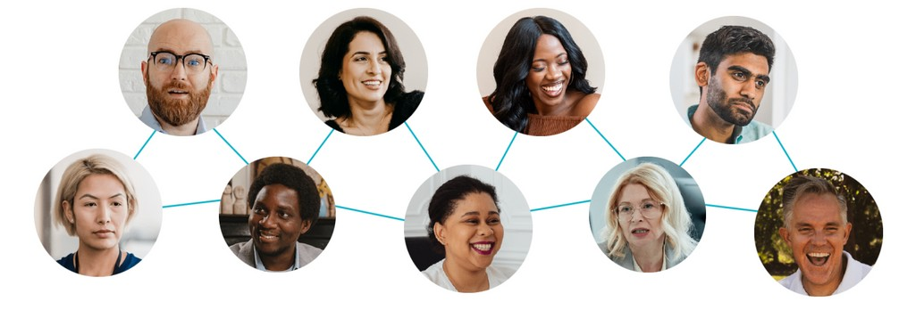

### About Us

*Inclusive Boards* is the UK's leading board diversity practice. We have worked alongside over 300 organisations to provide support with Board recruitment, development and governance reviews. We strive to be at the forefront of equity and diversity, and believe that everyone should be represented at Board level. Additionally, we also provide bespoke training sessions on a variety of subjects including personal branding, inclusive recruitment practices and board structures and governance as well as delivering leadership development programmes for underrepresented leaders across a range of sectors.

### Why Not Get in Touch?

If you think we can help to improve diversity on your Board, please don’t hesitate to contact us via [hello@inclusiveboards.co.uk](mailto:hello@inclusiveboards.co.uk).

If you aspire to join a Board, you can sign up to become a candidate on our website and be notified of the latest opportunities as and when they become available.

[**www.inclusiveboards.co.uk**](http://www.inclusiveboards.co.uk/)

@InclusiveBoards

https://linkedin.com/company/inclusive-boards