**Action for Happiness Trustee Candidate Pack 2021**

**Welcome from Our Chair**

**Welcome! I’m delighted that you’re considering joining us at Action for Happiness and supporting our important work. Our mission is to promote a happier world, by creating a culture that prioritises wellbeing and kindness. We do this by helping people get together regularly to learn evidence-based skills for happier living, feel a sense of belonging and commit to personal action to create more happiness, both for themselves and others.**

**As a Trustee, your role will be to work with our Board to set the strategic direction for our work and oversee the effective running of the organisation. You will focus on the key issues, opportunities and risks facing the charity and provide guidance on strategic direction to our Director and team. You will also act as an ambassador with key external audiences, help us build relationships with potential funders, and demonstrate leadership on our commitment to diversity and inclusion.**

**We have made encouraging strides in our first decade, building an online following of over 1 million people, a core movement of 275,000 signed up members and an incredible network of passionate volunteers running life-changing courses and groups in their local communities. Our work has also been evaluated in an independent peer-reviewed Randomised Controlled Trial, showing that it brings significant benefits in terms of enhancing wellbeing, reducing mental health issues and encouraging pro-social behaviour. We now have ambitious plans for the coming years and hope to significantly scale-up our reach and impact.**

**In the words of our Patron, the Dalai Lama: “Happiness is not something ready made; it comes from your own actions”. We believe in empowering people to prioritise wellbeing and contribute to a happier and kinder world. And by joining as Trustee you have a chance to make a really meaningful difference to this vital mission. We very much look forward to your application.**

[**Professor Lord Richard Layard**](https://cep.lse.ac.uk/_new/people/person.asp?id=970)

**Chair of Trustees**

**Professor of Economics at London School of Economics (LSE); founder of Centre for Economic Performance and Head of Well-Being program. Author of best-selling books Happiness and Thrive.**

**About Action for Happiness**

Action for Happiness is a movement of people committed to building a happier and more caring society. We want to see a fundamentally different way of life - where people care less about what they can get just for themselves and more about the happiness of others.

We bring together like-minded people from all walks of life and help them take practical action, drawing on the latest scientific research. We are backed by leading experts from diverse fields including psychology, education, economics and social innovation.

Members of the movement make a simple pledge: to try to create more happiness in the world around them. We provide ideas and resources to enable people to take action at home, at work or in their community. Many of our members form local groups to take action together.

We have no religious, political or commercial affiliations and welcome people of all faiths (or none) and all parts of society. We were founded in 2010 by Richard Layard, Geoff Mulgan and Anthony Seldon. Our patron is the Dalai Lama.

**What We Do**

**Action for Happiness helps people take action to improve wellbeing…**

For themselves and others. Our vision is a happier and kinder society, with fewer people suffering (e.g. due to mental ill health or social isolation) and more people feeling good, functioning well and helping each other. We deliver our mission in a variety of ways:

**We bring the science of wellbeing to life**

* via our Ten Keys to Happier Living resources, introductory programme and public events

**We help people take action to boost wellbeing**

* via our monthly themes and daily actions as seen in our calendars and app

**We bring people together for deeper transformation**

* via our local groups and life-changing face-to-face courses

**Ten Keys to Happier Living**

Action for Happiness has developed the 10 Keys to Happier Living based on a review of the latest scientific research relating to happiness.

Everyone’s path to happiness is different, but the research suggests these Ten Keys consistently tend to have a positive impact on people’s overall happiness and well-being. The first five (GREAT) relate to how we interact with the outside world in our daily activities*. The second five (DREAM) come more from inside us and depend on our attitude to life.

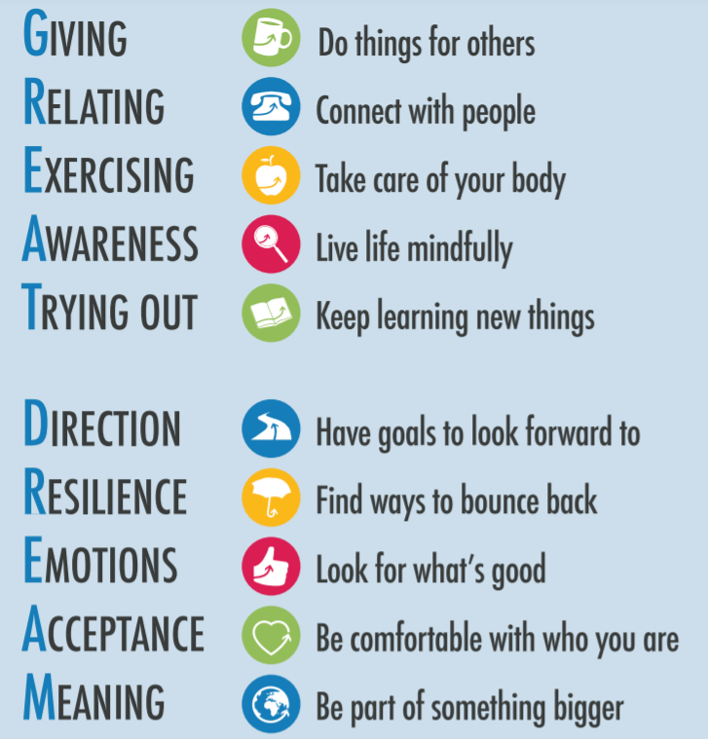

**Commitment to Equality, Diversity and Inclusion**

We are committed to increasing equality, diversity and inclusion within our company. This means reflecting critically on issues of diversity and inclusion within all that we do, identifying and taking appropriate actions to reduce inequality.

We welcome applications from anyone regardless of ethnicity, heritage, gender, disability, sexuality, religion, socio-economic background or other differences.

Therefore, during the application process we commit to:

* Paying for childcare and care costs whilst you’re attending an interview.
* Paying for your travel costs to the office and back for interviews if they are held in person.
* Making any reasonable adjustments - for example ensuring we have sign language interpreters organised in advance if you’d like them.
* Providing this document in a Word document format readily available to download.
* Offering a first stage interview to Disabled applicants who meet the minimum criteria for the role.

If there is anything else you’re concerned about or think we could provide, please let us know.

You can find our diversity, equity, inclusion and belonging policy [here](https://www.actionforhappiness.org/diversity-equity-inclusion-belonging)

**The Role and Person Specification**

We are seeking a new Board Member - We’re particularly interested to hear from candidates who have skills in ONE or more of the following areas:

* Strategic Communications (including digital)
* Helping organisations to grow and scale-up operations
* Fundraising for non-profit organisations

**Person Specification**

* Experience of working in or with community groups who reach under-served or disadvantaged audiences
* A passion for our vision and goals
* Sound strategic vision and independent judgement
* Strong communications skills with the ability to work effectively as part of a friendly and collaborative team
* Senior leadership experience with networks in business, policy or charity sectors, or a related field
* An understanding of organisational change
* Demonstrable commitment to the principles of effective governance and financial management in charities
* Commitment to equality, diversity and inclusion

**ADDITIONAL INFORMATION**

**Term of office**

This is a volunteer role. We pay reasonable out of pocket expenses. The initial term is three years and Trustees are eligible for re-appointment at the expiry of that term.

**Time Commitment**

There are four Trustee Board meetings per year, lasting 2 hours each. Trustees may also be asked to join occasional sub-Committees or meetings with the team. Each Board meeting has prior reading which will take around 1 hour to review. We can accommodate joining remotely when needed.

**Location**

Action for Happiness, WeWork, 3 Waterhouse Square, 138 Holborn, London EC1N 2SW

**Learning & Development**

We are committed to supporting Board Members learning and development through training and our informal learning sessions.

**Conflict of Interest**

All candidates will be asked to disclose any actual, potential or perceived conflict of interest, and these will be discussed with the candidate to establish whether and what action is needed to avoid a conflict or the perception of a conflict.

**Role as an Ambassador**

Board members are expected to be good ambassadors for Action for Happiness. Their behaviour at all times should enhance and protect the reputation of Action for Happiness. Board members should take every opportunity to champion Action for Happiness and support its mission and values.

**How to Apply**

The recruitment process is being undertaken by Inclusive Boards on behalf of Action for Happiness. If you wish to apply for this position, please supply the following by 23.59 30/01/2022

* A detailed CV setting out your career history, with responsibilities and achievements.
* A covering letter (maximum two sides) highlighting your suitability for the role and how you meet the person specification. Please note that the covering letter is an important part of your application and will be assessed as part of your full application.
* Please provide details of two professional referees together with a brief statement of their relationship to you and over what period of time they have known you.
* Referees will not be contacted without your prior consent.
* Diversity monitoring form - your data will be stored separately from your application and will at no time be connected to you or your application.

If you have any questions or would like to arrange a call to discuss the role please email A4H@inclusiveboards.co.uk or call 0207 267 8369.

Please send your CV and cover letter to A4H@inclusiveboards.co.uk or visit www.inclusiveboards.co.uk/opportunities to apply online.