Candidate Information Pack

Organisation: Cambridgeshire and Peterborough NHS Foundation Trust

Vacancy: Chair of the Trust Board

Welcome to Potential Applicants

Thank you for your interest in our Chair of the Board position with Cambridgeshire and Peterborough NHS Foundation Trust.

‘After being Chief Constable in Cambridgeshire this role has given me a unique insight into another corner of our public services alongside a real appreciation for the valuable work delivered by our often invisible mental health services. Initially I wasn’t sure the role was for me but the proof it was, together with the satisfaction it has given and hopefully the value I have been able to add, is evident after completing not one but three terms as Chair! And now it’s your turn…’ - Julie Spence, Trust Chair OBE

‘Julie will be a hard act to follow, but CPFT’s governors are confident that we will be able to appoint a worthy successor. We care passionately about the work of the Trust and we are looking for an outstanding candidate who shares our concerns, and who will be equally ready to celebrate success. Access to services, patient outcomes, support for carers, the integration of physical and mental health, staff wellbeing and working with our colleagues across the ICS are just some of our key interests. And we are proud of the Trust’s leading role in research. We look forward to hearing your ideas!’ - Keith Grimwade, Lead Governor

Trust Values and Candidate Information

CPFT values and promotes diversity and is committed to equality of opportunity for all. Appointments are made on merit from the widest possible pool of candidates.

We believe that the best Trust Boards are those that reflect the communities they serve. We welcome applications from all; but particularly from women, people from local black and minority ethnic communities, and disabled people who we know are under-represented in important leadership roles.

Our recruitment processes are conducted in accordance with the Code of Governance to ensure that they are made on merit after a fair, open and transparent process, to ensure the best people are appointed.

Our Vision

Together we will support our communities to live healthier lives.

Our Purpose

CPFT strives to improve the health and wellbeing of the population we care for, and to support and empower our citizens to lead a fulfilling life.

Our PRIDE Values and Behaviours

**Professionalism** - We will maintain the highest standards and develop ourselves

**Respect** - We will create positive relationships

**Innovation** - We are forward thinking, research-focused and effective

**Dignity** - We will treat you as an individual

**Empowerment** - We will support you

Contents

* The Opportunity
* About CPFT
* The Person Specification
* Role of the NHS Board and Chair
* Role Description
* Chair Competencies
* Appendices:
* Appendix 1 - Terms of Appointment
* Appendix 2 - Making an Application
* Appendix 3 - Key Dates

The Opportunity

We are looking for an exceptional, high quality and performing leader to take over Chairmanship of the Cambridgeshire and Peterborough NHS Foundation Trust (CPFT).

This is an unique opportunity to help shape the future of local services. We need your talent and expertise to transform services and make a positive difference to the communities across Cambridgeshire, as an essential and active partner of the Cambridgeshire and Peterborough Integrated Care Board.

The successful candidate will have a pivotal role in helping improve outcomes for patients and their families; reducing health inequalities across the county, to work with committed, determined staff in a research-focused Trust that constantly strives to learn and to do things differently and better; and to support and challenge the wider healthcare system to deliver better, integrated care.

The prospect of welcoming a world-class leader to the Trust is exciting. We have the fantastic opportunity to bring health and care closer together than ever before, across one of the largest and most ambitious Integrated Care System areas in the country, and together achieve the remarkable potential. We offer you a role that will be stimulating and rewarding, and which will allow you to make a real difference to the health and wellbeing of the people of Cambridgeshire and Peterborough. We very much look forward to hearing from you.

About CPFT

Here at CPFT we are dedicated to providing high quality care with compassion. We provide a wide range of mental health, physical health, specialist, learning disability and neurorehabilitation community and hospital services to a population of circa 1 million people in the East of England.

CPFT is a health and social care organisation, providing integrated older adult physical and mental health services, adult mental health and learning

disability services, and children’s mental health services, across Cambridgeshire and Peterborough, and children’s community health

services in Peterborough.

Services include:

* Adult mental health
* Forensic and specialist mental health
* Older people’s mental health
* Children’s mental health
* Children’s community
* Older people's and adult community
* Specialist learning disability
* Primary care and liaison psychiatry
* Substance misuse
* Social care
* Research and development

CPFT supports a population of just under a million people and employs nearly 4500 staff.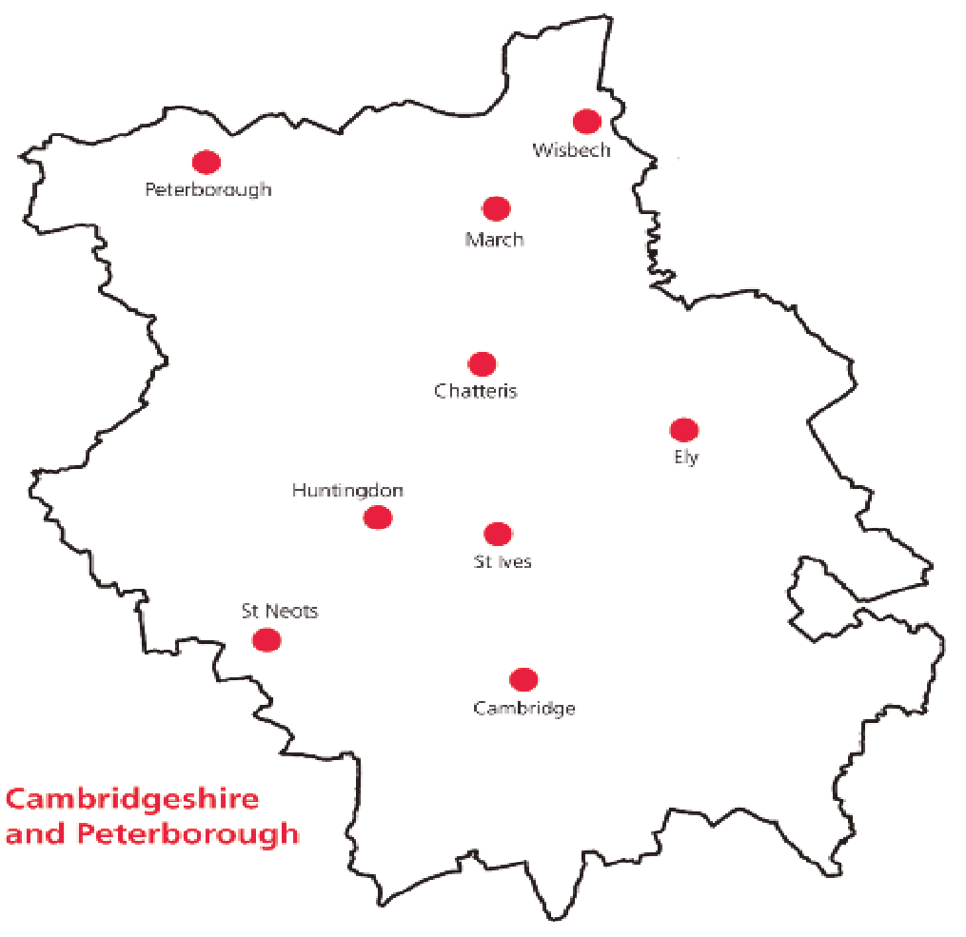

Our largest bases are at the Cavell Centre, Peterborough, and Fulbourn Hospital, Cambridge, but our staff are based in over 50 locations.

We are a University of Cambridge Teaching Trust and member of Cambridge University Health Partners, working together with the University of Cambridge Clinical School and Anglia Ruskin University.

Together with global, national and local partners we conduct high-quality and ground-breaking research into mental and physical health and support innovation to improve patient care.

We collaborate across the Cambridgeshire and Peterborough Integrated Care System, working with colleagues in local government, primary care, secondary care, third and voluntary sector health and care organisations to improve the delivery of care for our local population.

Trust Services

* Children and Young People Mental Health and Community Physical Health Services in Peterborough - Over 500 staff dedicated to providing integrated physical and mental health support to children, young people, and their families.
* Adult and Specialist Inpatient and Community Mental Health Services - 1500 staff providing care planning, treatment and support for people aged 18-64 with a range of serious and enduring mental health needs.
* Integrated Older Adult Physical and Mental Health Services - Almost 1700 staff delivering care planning, treatment, and support to meet the physical and mental health needs of our residents.
* Learning Disabilities: Community, Inpatient Services and Learning Disabilities Partnership with Cambridgeshire County Council - directly providing access to specialist nurses, psychiatrists, psychologists, therapists, allied health professionals and care managers through its integrated community teams.
* Social Care - Under partnership agreements with the two local authorities, we host around 50 staff providing social care support to help people live more independent and comfortable lives.

Priority Aims

Our high level priority aims for the next 3 years, which align to the Integrated Care System (ICS) strategic approach, are:

* Working in partnership to deliver best care
* People at the heart of everything we do
* A system leader in innovation and research
* Making best use of resources

The Trust has launched a new three-year strategy with key programmes to support delivery.

The 2022-25 Trust Strategy is available [here](https://www.cpft.nhs.uk/board-of-directors).

Key Challenges

Cambridgeshire and Peterborough NHS Foundation Trust (CPFT) is rated 'Good' overall by the Care Quality Commission with ambition to become an outstanding organisation. The top three challenges facing the Trust are:

* Quality, Safety and Waiting Times - As we emerge from the pandemic, the Trust continues to hold quality and safety of services as its key priority, and is working operationally to understand and support the impact COVID-19 has had on service delivery. A core risk in this area is demand outweighing established capacity and provision, and the timeframe of patients being clinically assessed and treated, which could potentially worsen with further interruptions to service delivery due to Covid and staff absence. In addition, the Trust is experiencing increased numbers of patients presenting with acute mental health issues, particularly within children and adolescent services, who require specialist input.
* Workforce - Making CPFT a brilliant place to work is one of the Trust’s highest priorities, with key challenges being addressing workforce shortages and supporting a fatigued workforce. The Trust has plans in place aimed at addressing workforce shortages through recruitment, retention, and workforce transformation. In addition, robust measures to support our workforce through ongoing development of a health and wellbeing offer are in place. Given the current economic climate this includes the potential future risk of industrial action, increased winter COVID-19 and flu cases within the communities we serve, which potentially impact upon service delivery, targets and quality standards.
* Sustainable Finances - The NHS must make significant efficiencies to balance the rising costs with increasing demand. CPFT has an ambitious and challenging financial plan and must work together with health and care partners at ‘Place’ and across the Cambridgeshire and Peterborough Integrated Care System, to benefit patients, community and staff and increase its role in improving the health and prosperity of the local population.

Person Specification

We are seeking candidates who want to use their energy, skills and experience to help drive the delivery of sustainable healthcare services for the people of Cambridgeshire and Peterborough and surrounding areas.

Required skills, experience and attributes:

* Values - A clear commitment to the NHS and the Trust’s values and behaviours.
* Strategic - Experience of leading and delivering against long-term vision and strategy. Experience leading transformational change, managing complex organisations, budgets and people.
* People - Strong interpersonal, communication and leadership skills. Experience of building effective teams, encouraging change and innovation and shaping an open, inclusive and compassionate culture through setting the right tone at the top and championing diversity at, and across, all levels with a strong focus on the experience of all staff and patients.
* Professional Acumen - Prior board experience (any sector, executive or non-executive); Evidence of successfully demonstrating the NHS provider chair competencies in other leadership roles. An ability to identify and address issues, including underperformance, and to scrutinise and challenge information effectively for assurance.
* Outcomes Focus - A demonstrable interest in health and social care and a strong desire to achieve the best sustainable outcomes for all patients and service users through encouraging continuous improvement, clinical excellence and value for money. Strong understanding of financial management, with the ability to balance the competing objectives of quality, operational performance and finance, with an appreciation of constitutional and regulatory NHS standards.
* Partnership - A desire to engage with the local population and to collaborate with senior stakeholders across the health and care system. Experience in managing conflict, finding compromise and building consensus across varied stakeholder groups with potentially conflicting priorities.
* Desirable Experience - Prior experience as a Non-Executive Director (any sector); on an NHS board; Professional qualification or equivalent experience; Prior senior experience of complex organisation. Information provided by applicants will be relied on to assess whether sufficient personal responsibility and achievement have been demonstrated in previous/other roles, to satisfy the experience being sought.

Role of the NHS Board and Chair

NHS boards play a key role in shaping the strategy, vision and purpose of an organisation. They hold the organisation to account for the delivery of strategy and ensure value for money. NHS boards are also responsible for ensuring that risks to the organisation and the public are managed and mitigated effectively.

Led by an independent chair and composed of a mix of both executive and independent non-executive members, the board has a collective responsibility for the performance of the organisation. The Chair of the Board ensures the board is focused on improving outcomes in population health and healthcare, and fosters a culture of learning and continuous improvement, with a particular focus on quality, safety, access, and patient experience.

The purpose of NHS boards is to govern effectively, and in so doing build patient, public and stakeholder confidence that their health and healthcare is in safe hands. This fundamental accountability to the public and stakeholders is delivered by building confidence:

* in the quality and safety of health services;
* that resources are invested in a way that delivers optimal health outcomes;
* in the accessibility and responsiveness of health services;
* that patients and the public can help to shape health services to meet their needs; and
* that public money is spent in a way that is fair, efficient, effective and economic.

Role Description

To carry out their role effectively, the Chair of the Board must cultivate a strong, collaborative relationship with the Chief Executive and Lead Governor. Many responsibilities will be discharged in partnership with the Chief Executive, however it is important that the Chair is clear about individual and shared roles, and their respective responsibilities towards the unitary board.

Together, the Chair of the Board and the Chief Executive set the tone for the whole organisation. They are ultimately responsible for ensuring that the population the Trust serves receive the best possible care in a sustainable way.

The Chair of the Board has a unique role in leading the Trust board and chairing the Council of Governors. The role combines the duty to lead effective governance, consistent with the Nolan principles and NHS values, with securing a long-term vision and strategy for the organisation. Fundamentally, the Chair of the Board is responsible for the effective leadership of the board. They are crucial in creating the conditions necessary for overall board and individual director effectiveness. Central to the chair’s role are five key responsibilities:

* Strategic - In their **strategic leadership** role, the Chair is responsible for:
* Working as an essential and active partner of the ICB.
* Ensuring the whole board of directors plays a full part in developing and determining the Trust’s vision, values, strategy and overall objectives to deliver organisational purpose and sustainability.
* Ensuring the Trust’s strategy aligns with the principles guiding the NHS and the NHS values.
* Ensuring the board identifies the key risks the Trust faces in implementing its strategy; and determines its approach and attitude to providing effective oversight of those risks and controls.
* Holding the Chief Executive to account for performance.
* People - In their role **shaping organisational culture** the Chair is responsible for:
* Providing visible leadership in developing a healthy, open and transparent patient-centred culture for the organisation, where all staff have equality of opportunity to progress, the freedom to speak up is encouraged, and ensuring that this culture is reflected and modelled in their own and in the board’s behaviour and decision-making.
* Leading and supporting a constructive dynamic within the board, enabling grounded debate with contributions from all directors.
* Promoting the highest standards of ethics, integrity, probity and corporate governance throughout the organisation and on the board.
* Demonstrating visible ethical, compassionate and inclusive personal leadership by modelling the highest standards of personal behaviour and ensuring the board follows this example.
* Ensuring that constructive relationships based on candour, trust and mutual respect exist between executive and non-executive directors.
* Developing effective working relationships with all the board directors, particularly the Chief Executive, providing support, guidance and advice.
* In their role **developing the capacity and capability**, the Chair is responsible for:
* Ensuring the board sees itself as a team, has the right balance and diversity of skills, knowledge and perspectives, and the confidence to challenge on all aspects of clinical and organisational planning.
* Lead on continual director development of skills, knowledge and familiarity with the organisation and health and social care system, to enable them to carry out their role on the board effectively.
* Developing a board that is genuinely connected to and assured about staff and patient experience, as demonstrated by appropriate feedback and other measures, including the Workforce Race Equality Standard (WRES); Workforce Disability Equality Standard (WDES); and Equality Delivery System (EDS).
* Partnerships - In their role as an **ambassador,** leading in developing **relationships** and **partnership working**, the chair is responsible for:
* Promoting an understanding of the board’s role, and the role of non-executive and executive directors.
* Representing the organisation externally, developing and facilitating strong partnerships, and promoting collaborative, whole-system working through engagement.
* Ensuring effective communication with stakeholders creates board debate encompassing diverse views, and giving sufficient time and consideration to complex, contentious or sensitive issues.
* Working with the Chair of the ICB and other Trust Chairs across the system and being a member of the wider Cambridgeshire and Peterborough Integrated Care Partnership group.
* Professional Acumen - In their role as **governance lead**, the chair is responsible for:
* Making sure the board operates effectively and understands its own accountability and compliance.
* Personally doing the right thing, ethically and in line with the NHS values, demonstrating this to and expecting the same behaviours back.
* Leading the board in establishing effective and ethical decision-making processes setting an integrated board agenda relevant to the Trust’s current operating environment.
* Ensuring that the board receives accurate, high quality, timely and clear information that is related and fit for purpose.
* Ensuring board committees are properly constituted and effective.
* In their role as **facilitator of the board**, the Chair is responsible for:
* Providing the environment for agile debate.
* Ensuring the board collectively and individually applies sufficient challenges, balancing the ability to seize opportunities while retaining robust and transparent decision-making.
* Facilitating the effective contribution of all members of the board, drawing on individual skills, experience, knowledge and independence.
* Working with and supporting the trust board secretary in establishing and maintaining the board’s annual cycle of business.
* Patient Focus - In their role as a **catalyst for change**, the Chair is responsible for:
* Ensuring all board members are well briefed on external context.
* Fostering a culture of innovation and learning, by being outward-looking, promoting and embedding innovation, technology and transformation through the board business and debate.
* Promoting academic excellence and research as a means of taking health and care services forward.
* Ensuring performance is accurately measured against constitutional and Care Quality Commission ‘well-led’ standards.
* Ensuring performance on equality, diversity and inclusion for all patients and staff is accurately measured and progressed against national frameworks, including WRES, WDES and EDS.
* Above all, ensuring the board maintains an unrelenting interest in and focus on the continuous improvement and self-assessment of patient safety, experience and clinical outcomes.

Chair Competencies

The competency framework describes the core competencies required in the NHS provider chair’s role, in the context of the NHS principles and values in the NHS Constitution. We envisage that the competency framework will be used to recruit and appraise chairs. The figure below shows this and details the associated requirements under each competency:

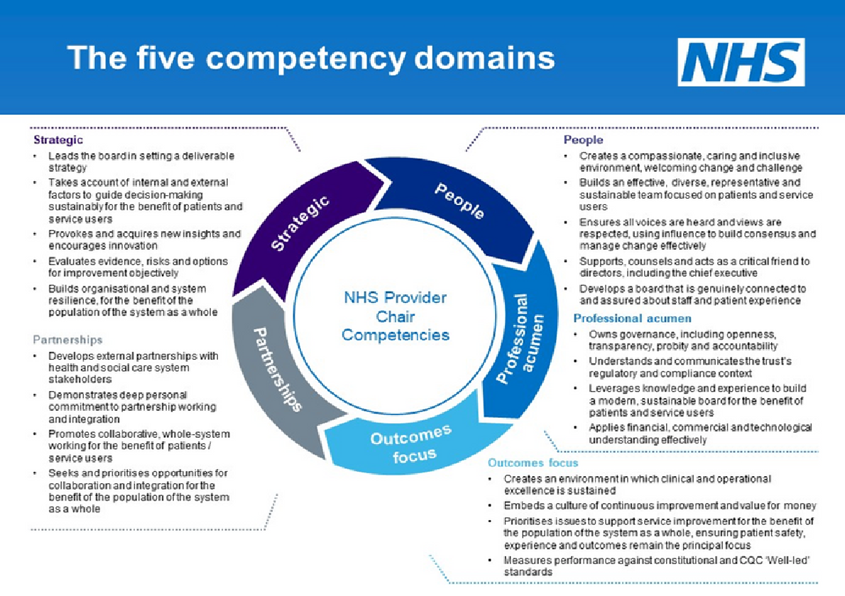

Appendix 1: Terms of Appointment

Current remuneration for this role is £47,100 per annum.

The initial appointment will be for a period of up to three years, after which you may be considered for review and a further three year term, followed by an annual review and appointment for an additional three years. The maximum term of office is nine years. Reappointment is subject to the needs of the organisation and performance in the role.

You will have considerable flexibility to decide how you manage the time needed to undertake this role. On average, it will require 2.5 days per week, with variable commitment, and includes preparation time away from the trust and the occasional evening engagement and event.

Applicants should live in or have strong connections with the area served by the trust.

Given the significant public profile and responsibility members of NHS Boards hold, it is vital that those appointed inspire confidence of the public, patients and NHS staff at all times.

CPFT will make a number of specific background checks to ensure that those we appoint are “fit and proper” people to hold these important roles.

Appendix 2: Making an Application

For more information about the trust, such as business plans, annual reports, and services, please visit our website: [www.cpft.nhs.uk](http://www.cpft.nhs.uk/)

For more information about the Council and Governors and their fundamental, please visit: [The Board of Directors | CPFT NHS Trust](https://www.cpft.nhs.uk/board-of-directors)

For more information about the Cambridgeshire and Peterborough Integrated Care System, please visit: [Cambridgeshire & Peterborough Integrated Care System | CPICS Website](https://www.cpics.org.uk/)

The recruitment process is being supported by Inclusive Boards on behalf of CPFT. If you would like to apply, please supply the following information by no later than **23.59hrs on 15/01/2023**:

* A detailed CV that includes your address and contact details, setting out your career history, with responsibilities and achievements.
* A covering letter that highlights your motivation for applying and your understanding of the NHS and the role. Please outline your personal responsibility and achievement within previous roles and how your experience matches the person specification. Please note that the covering letter is an important part of your application.
* Details of three professional referees together with a brief statement of their relationship to you and over what period of time they have known you. References will be taken prior to interview and may be shared with the selection panel. Referees will not be contacted without your prior consent.

All candidates are also requested to complete an online Equal Opportunities Monitoring Form. This form will not be disclosed to anyone involved in assessing your application.

The preferred method of application is online at: [www.inclusiveboards.co.uk/opportunities](http://www.inclusiveboards.co.uk/opportunities)  
If you are unable to apply online please email your application to: [CPFT@inclusiveboards.co.uk](mailto:CPFT@inclusiveboards.co.uk)

For an informal and confidential discussion with the Lead Governor, Chief Executive, or Director of People and Business Development, please contact the Corporate Office on T: 01223 219473.

Appendix 3: Key Dates

**The closing date for receipt of applications is**: Midnight on 15/01/23.

**The panel will shortlist on:** 03/02/23.

**Interviews and Stakeholder Panel will take place on:** 20/02/23. Candidates will be invited to the Trust to meet key stakeholders.

**Proposed start date:** April/May 2023.