**Trustee recruitment pack**

**Victim Support**

**www.victimsupport.org.uk**

Welcome from Andrew

**Dear Applicant,**

Thank you for your interest in becoming a member of our Board of Trustees   
at Victim Support (VS). We are looking for up to three new trustees who will be ambassadors for VS and our work, and who will use their knowledge, skills and experience to shape the strategic direction of VS.

As an independent charity, VS provides personalised support to help people manage after crime and feel safer. We also inform victims of their rights and the services that they may be entitled to and ensure their voices are heard throughout their support and beyond.

We deliver a range of specialist services including services for people affected by domestic abuse and sexual violence, fraud and services dedicated to children and young people. Our National Contact Centre, based in Wales, provides a range of services including our free 24/7 Supportline and live chat services.

We believe having a diverse workforce at all levels allows us to represent the communities we serve and connect better with people affected by crime. We would like our Board of Trustees to be as diverse as the communities we are working with. As a result, whilst we would encourage anyone interested to consider an application, we would be particularly welcome applications from those from groups currently under-represented on the Board, including disabled people, people from racialised communities and people who identify as LGBTQ+. We also offer a full induction and training opportunities to all Trustees to support them fulfil their role

We want to see a world where there are fewer victims, and for those affected   
to have stronger rights, better support and real influence in the criminal justice system. If you join our Board of Trustees, you will have the opportunity to   
make a real impact and be part of our success story.

We look forward to hearing from you.

Best wishes,

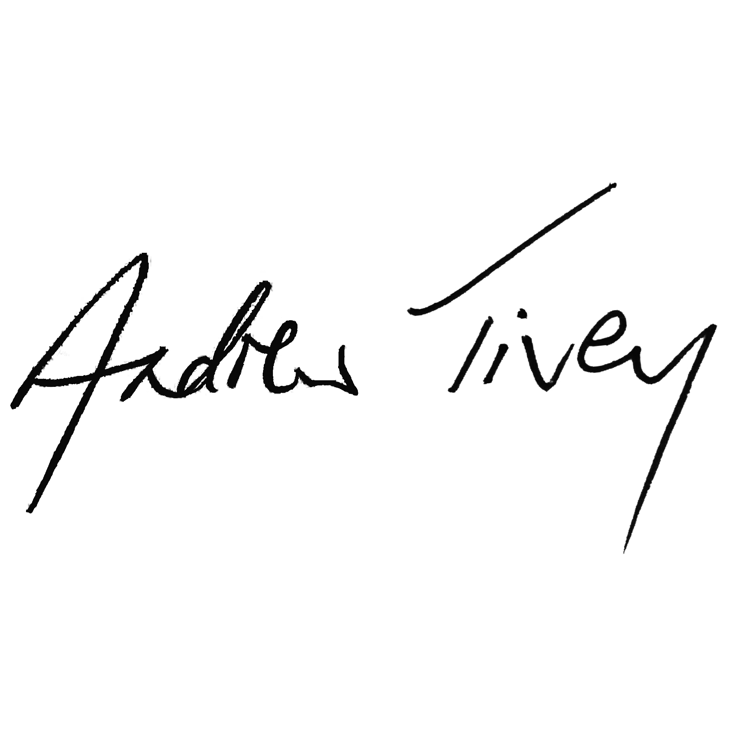

**Andrew Tivey**Chair of Trustees  
June 2023

About Us

Who We Are

Victim Support is an independent charity that provides free, independent and confidential support to anyone affected by crime and traumatic events in England and Wales.

We provide personalised support to help people manage after crime and feel safer. We also inform victims of their rights and the services that they may be entitled to and ensure their voices are heard throughout their support and beyond.

Victims, those close to them and witnesses to the crime are our focus and over the years we have developed unrivalled expertise when it comes to their needs and their journey through the criminal justice system.

**Watch this** [**short video**](https://www.youtube.com/watch?time_continue=71&v=d6VZxyNMqZc&embeds_euri=https%3A%2F%2Fwww.victimsupport.org.uk%2F&feature=emb_logo) **to find out more about what we do and the difference we make**

[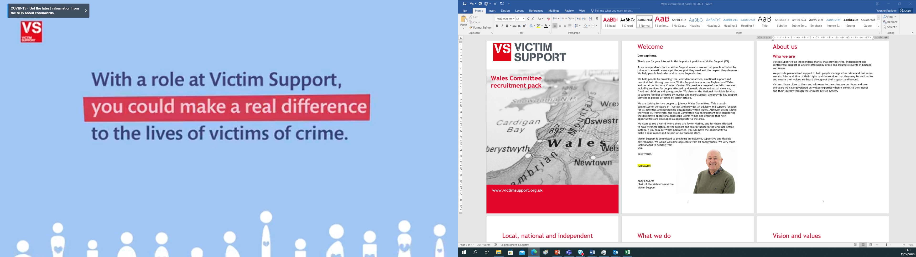](https://www.youtube.com/watch?time_continue=71&v=d6VZxyNMqZc&embeds_euri=https%3A%2F%2Fwww.victimsupport.org.uk%2F&feature=emb_logo)

Link here - https://www.youtube.com/watch?time_continue=71&v=d6VZxyNMqZc&embeds_euri=https%3A%2F%2Fwww.victimsupport.org.uk%2F&feature=emb_logo

Local, National and Independent

**We Are Local**Local needs and priorities help determine the services we offer in communities across England and Wales. Our skilled local staff and volunteers are embedded in the communities in which they live and work.

**We Are National**

We provide some services for people across the whole of England and Wales. These include the National Homicide Service, our 24/7 free-to-call Supportline, our live chat service and our online self-help platform, My Support Space

**We Are Independent**

We are independent of the police, the government, local authorities, immigration services and the criminal justice system

What We Do

**For The Individual Affected By Crime**

**Safety**We help people feel safer and more secure

**Inform**We help people understand their rights and feel empowered

**Validate**We ensure people feel listened to and understand their experience

**Reflect**We help develop strategies for coping with daily life and build resilience

**Connect**We ensure people have strong networks and have their voices heard

**For All People Affected By Crime**

**Speak**We speak with an informed national voice

**Highlight**We highlight the voices of victims

**Shape**We help shape legislation, policy and practice

**Collaborate**We collaborate and partner with other organisations

Mission, Vision And Values

Vision

**A world where there are fewer victims, but who have:**

* **stronger** rights
* **better** support
* **real** influence in the criminal justice system.

**Ambitions**

* **We will** have developed innovative new services that will meet new and emerging needs
* **We will** have empowered more people with specialist support and advocacy to feel safer and move on beyond the impact of the harm they have experienced
* **We will** have effected change by making the case for people to have stronger rights and feel respected by the criminal justice system.

Our Values

Everything we do is underpinned by our values, which drive our organisational culture; what sort of organisation we are, what we stand for and how we behave.

**We are:**

**Empowering**

* We work with people to shape the support that they receive, to develop their resilience and the skills to achieve their rights.
* We treat everyone with dignity and respect.
* We will ensure that the way we run VS at every level is informed by people with lived experiences of crime and harm and we will continue to develop the ways we involve and consult service users.

**Inclusive**

* VS is committed to ensuring that all of our services are equitable and accessible to all; that our employees and volunteers reflect the diversity   
  of the communities we serve, and that equality, diversity and inclusion   
  is embedded across our organisation.
* We will continue to develop channels to engage and consult with staff and volunteers to ensure their experience and voice is heard in the running of VS and the delivery of our services via the Staff Consultation Forum and the Volunteer Panel.

**Collaborative**

* We will work together locally in a positive Multi Agency approach to best meet the needs of individual people affected by crime. We will work closely with other like-minded organisations nationally and locally to campaign for improvements in the criminal justice system and to develop our respective and collective organisational strength.
* The environment affects us all now and for the future. We will work together and with other organisations to make VS a healthy place to work and visit.
* We are committed to continually improving our environmental performance, promoting the wellbeing of our teams and ensuring that   
  we minimise any adverse environmental impact from our activities.

**Independent**

* We are an independent charity. This enables us to work alongside people to represent their interests, access the services they need,   
  exercise their rights and support them to speak out.

Equality, Diversity and Inclusion

VS is committed to being an employer that enables all staff and volunteers to   
bring their whole selves to work. We strive to represent the diverse communities we serve and are passionate about creating an environment where all staff and volunteers feel respected and heard. Developing this inclusive culture is integral to us being able to meet our aim of ensuring that anyone who is a victim of crime gets the support they need.

Reaching this aim is also underpinned by a commitment to hearing the voices of, and involving victims, increasing our understanding of what our diverse communities want and need from us and ensuring that accessibility and inclusion sit at the heart of our services. We are proud to have been externally recognised for our work to embed EDI throughout our employment, volunteering and service delivery practices but we know we must continue this journey and adapt to the ever-changing landscape around us.

VS is actively committed to encouraging and promoting the positive contribution of our diverse service users in developing and improving our services. VS takes an intersectional approach to EDI, this means taking account of the multiple and intersecting identities that any of us can have, including those that are visible and non-visible and those that are included within equalities legislation and those that are not. We will ensure that equality, diversity and inclusion are reflected in our practices, policies and services. We are working towards the elimination of discrimination (whether direct, indirect or through victimisation or harassment) and will not tolerate any discrimination relating to issues of equality, diversity or inclusion. Everyone at VS has a responsibility to ensure equality; diversity and inclusion are upheld in all we do.

You can find out more about VS’ approach to EDI, including our EDI strategy,   
EDI Policy and information our EDI staff and volunteer groups on the dedicated [Equality, Diversity and Inclusion pages](https://www.victimsupport.org.uk/more-us/about-us/equality-diversity-and-inclusion/) of our website.

|  |
| --- |
|  |
|  |

We carry these commitments and ways of working through for trustees once in post and are committed to providing training opportunities. For example, mindful of the need to diversify the board space, we'd be delighted to support people with limited or no experience of trusteeship to undertake training and support development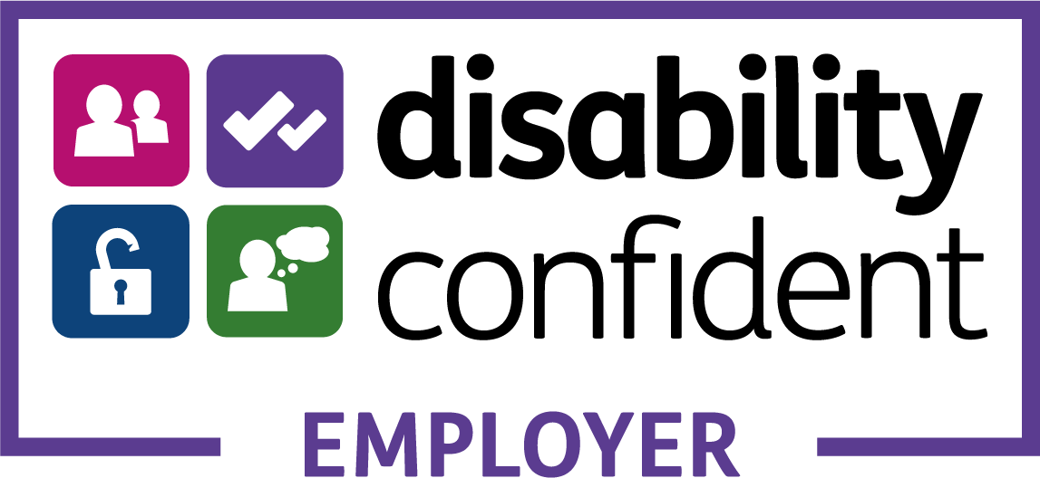.

We Make A Difference

786,574 people were offered information and support

30,905 live chats were handled by VS

30,190 calls to our supportline and Victim Information Line were answered

6,945 people created a My Support Space account

9,459 pieces of print, broadcast and online coverage that mentioned VS and our support for victims

6 research reports were published, building understanding and knowledge of victims experiences

Following Our Help and Support:

80% felt better to cope

76% felt safer

79% said their wellbeing has improved

There was a 95% satisfaction rate reported by people that have used our services

Governance Structures

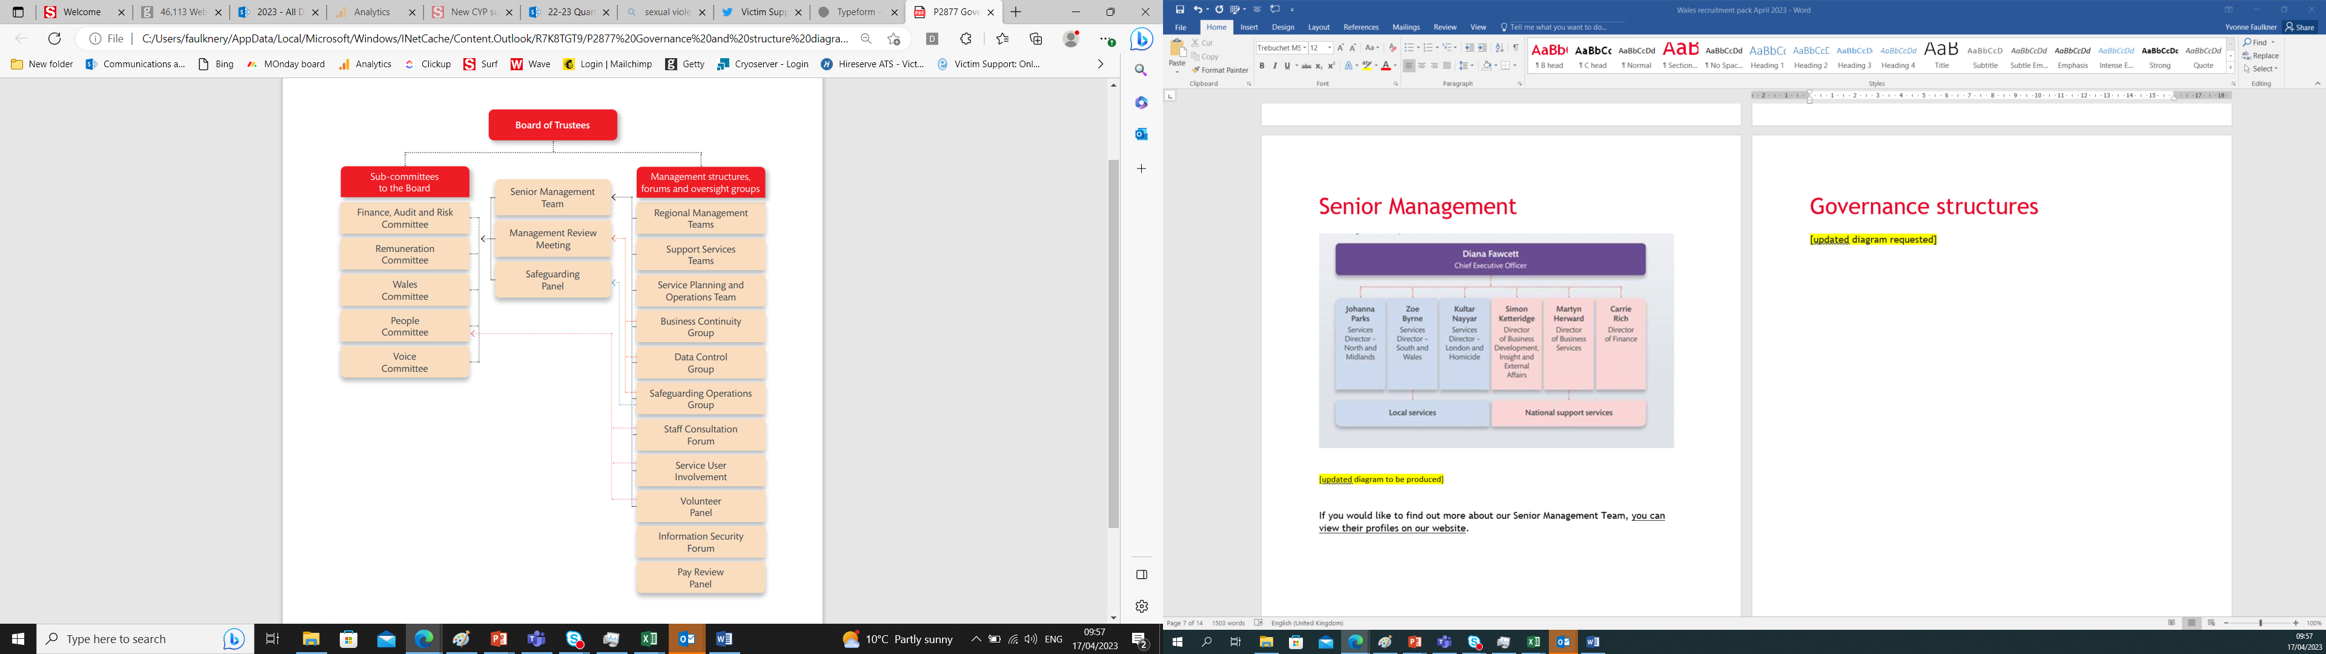Information about [Senior Management Team](https://www.victimsupport.org.uk/more-us/about-us/people/senior-management-team/) members and [Board of Trustees](https://www.victimsupport.org.uk/more-us/about-us/people/board-trustees/) can be found on the Victim Support website.

Our Board of Trustees

If you would like to find out a bit more about the Board, who they are and what they do, all our Trustee profiles can be found on our [website](https://www.victimsupport.org.uk/more-us/about-us/people/board-trustees) alongside information about the Senior Management Team**.** [**https://www.victimsupport.org.uk/more-us/about-us/people/board-trustees**](https://www.victimsupport.org.uk/more-us/about-us/people/board-trustees)

Being a Trustee

We are looking to appoint candidates to our Board of Trustees that:

* Make sure that the needs of victims, witnesses and families affected by tragic incidents and crime are always at the centre of decisions taken by VS.
* Will be an ambassador for VS and for our work.
* Help shape to the strategic direction of VS.
* Make sure VS has policies in place that comply with current legislation and promote good practice.
* Make sure that staff, money and other resources are used appropriately,   
  and that this is always monitored properly.
* Support the fundraising, income generation and outward facing activities   
  of the charity.
* Spend time with our services, getting to understand their work and ensuring they know what the role of a Trustee is.
* Participate in the cycle of meetings and make sure that decisions taken   
  at meetings are implemented.
* Attend training sessions, some of which are embedded into each Board meeting, to promote your knowledge and professional development in the role of Trustee.

As a Trustee you will need…

* To be committed to developing your knowledge and understanding   
  of how VS is run, including engagement work with local   
  or national services. Full training and support will be provided for   
  the successful applicants**.**
* To be committed to supporting and promoting VS’s vision and mission.
* To understand and believe firmly in the work that we do and our values
* To demonstrate stron g leadership skills.
* To be a creative thinker and help VS develop innovate new areas of work or support.
* To be committed to supporting VS values and EDI policy.
* To have excellent communication skills, and be able both to build agreement and challenge convention.
* To be an active member of the board, committing the time and thought needed.
* To be committed to VS’s statement of good governance (see Appendix 1).
* To complete a DBS check.
* To complete mandatory online learning and other training from time   
  to time.

We are particularly interested to hear from candidates with skills in ONE of the following areas:

* Finance
* Human resources
* Digital

As a Trustee you will NOT need…

* To have previous Board experience. We provide training and learning opportunities for all our Trustees.

Time Commitment

Trustees are asked to prepare for, attend and contribute to all Board meetings   
and encouraged to join sub-committees of the Board and ad hoc working groups   
as required. Meetings are held at different locations throughout England and Wales and online. Regular annual commitments would include:

* Four full-day meetings of the Board (during working hours)
* One Strategy Day
* It is encouraged to become a member of a Committee (People, Remuneration or Finance, Audit and Risk)
* Visits to local offices or services as appropriate
* Attendance at occasional fundraising or networking events.

We estimate that the annual commitment for our Trustees is ca. 8—10 days per year in total.

**Remuneration**

The position of Trustee is unpaid. However, all reasonable out-of-pocket   
expenses incurred on charity business will be reimbursed in line with our   
Volunteer Expenses Policy.

Term of office

Trustees are appointed for an initial term of three years, with the possibility   
of extension for a further period of three years.

Legal requirements in the role Trustee

All Trustees are individually and legally responsible for the charity they govern.   
If you would like to find out more about these responsibilities, the [Charity Commission](https://www.gov.uk/government/organisations/charity-commission) have released some helpful guidance: [The essential Trustee: what you need to know, what you need to do](https://www.gov.uk/government/publications/the-essential-trustee-what-you-need-to-know-cc3/the-essential-trustee-what-you-need-to-know-what-you-need-to-do#s3).

How To Apply

The recruitment process is being undertaken by Inclusive Boards on behalf of Victim Support. If you wish to apply for this position, please supply the following by 23.59 on 23/07/2023.

* A detailed CV setting out your career history, with responsibilities and achievements.
* A covering letter (maximum 2 sides) highlighting your suitability for the role and how you meet the person specification. Please note that the covering letter is an important part of your application and will be assessed as part of your full application.
* Details of two professional referees together with a brief statement of their relationship to you and over what period of time they have known you. Referees will not be contacted without your prior consent.

If you have further questions after reading this pack, please email victimsupport@inclusiveboards.co.uk or call 0207 267 8369.

Please visit [www.inclusiveboards.co.uk/opportunities](http://www.inclusiveboards.co.uk/opportunities) to apply online or send your CV and cover letter to victimsupport@inclusiveboards.co.uk

Victim Support is committed to inclusive working practices, so during the application process we commit to:

* Paying for care and childcare if required whilst you are at Victim Support interviews.
* Paying for any reasonable travel costs for interviews held in person.
* Making any reasonable adjustments – for example ensuring have a sign language interpreter organised in advance if you’d like them.
* Providing this document in a Word document format readily available to download.

If there is anything else you are concerned about or think we could provide, please let us know.

Appendix 1: VS’s Statement   
Of Good Governance

As a Trustee I will...

Hold ultimate responsibility for the effective, ethical and legal running   
of the charity.

Work in line with the vision, mission and values of VS.

Work with personal integrity, managing my own conflicts of interest and declaring these to the Board as and when they arise.

Promote my own continual professional development and undertake any additional training where necessary to understand the work we do at VS.

Act as a leader and ambassador for the organisation.

As a Board we will...

Work in line with the [Charity Governance Code](https://www.charitygovernancecode.org/en).

Champion the voice of our service users.

Work alongside the Senior Management team to develop and evaluate our organisational Strategy.

Constructively challenge both ourselves and each other, to ensure we are working in the best interest of the charity.

Be open and transparent in our decision-making processes.

Evaluate our performance as a group, identify any potential gaps in our collective skillset and undertake work to fill these gaps.



We are an independent charity offering free, confidential support to people affected by crime and traumatic incidents.

For information and support, contact us by:

■ calling Supportline 08 08 16 89 111

■ using Text Relay (add 18001 before any of our phone numbers)

■ Online: victimsupport.org.uk

To find out how you can help us, visit victimsupport.org.uk/get-involved

VictimSupport @VictimSupport victimsupport_uk

victimsupport.org.uk

Published by Victim Support. President HRH The Princess Royal

Victim Support, Ground Floor, Building 3, Wern Fawr Lane, Old Str. Mellons, Cardiff CF3 5EA

Charity registration: 298028. Company no: 2158780 Registered in England. Limited by guarantee. Registered office as above.

©Victim Support 2023 Imagery: © Getty Images

#### About Us

*Inclusive Boards* is the UK's leading board diversity practice. We have worked alongside over 300 organisations to provide support with Board recruitment, development and governance reviews. We strive to be at the forefront of equity and diversity and believe that everyone should be represented at Board level. Additionally, we also provide bespoke training sessions on a variety of subjects including personal branding, inclusive recruitment practices and board structures and governance as well as delivering leadership development programmes for underrepresented leaders across a range of sectors.

#### **Contact us today**

Improve diversity on your Board, please don’t hesitate to contact us via [hello@inclusiveboards.co.uk](mailto:hello@inclusiveboards.co.uk).

To join a Board, sign up to become a candidate via our website and be notified of the latest opportunities as and when they become available.

**Web**: [**www.inclusiveboards.co.uk**](http://www.inclusiveboards.co.uk)

**Instagram/Twitter: @InclusiveBoards**

**Linkedin: https://linkedin.com/company/inclusive-boards**