- Cover –

Directors (Trustees ) x 2 Candidate Information Pack - Wickersley Partnership Trust
- Welcome from our CEO

A very warm welcome to Wickersley Partnership Trust.

Wickersley Partnership Trust (WPT) was founded in 2014, and I became CEO in 2018. WPT exists to further the interests of the young people that it serves. We believe that education empowers and enriches: our vision is to send all children into an ever-changing world able and qualified to play their full part in it. We are committed to ensuring that all students have the best educational experience possible. and we know that recruiting the highest quality colleagues is key to realising this mission.

As a parent myself, I am a strong believer that if it isn’t good enough for my own children, it isn’t good enough for the children of the communities we serve. I uphold these standards in every decision I take as CEO.

Our ethos is clear: we are one school on many different sites. Our innovative use of System Leadership ensures that colleagues are well supported and work collaboratively so that all students, regardless of the school they attend, receive the same high-quality education and experiences.

Our Directors have ultimate responsibility for directing the affairs of the Trust, and must ensure that it is solvent, well-run, and delivering the charitable outcomes for the benefit of the public for which it has been set up.

We are seeking two new Directors (Trustees) who will join the Audit and Risk and Finance subcommittees respectively. We are seeking individuals with a strong interest in and commitment to education as well as an understanding of the governance arrangements of the education and charity sectors.

This is an exciting time for the Trust as a Director. Our Directors ensure clarity of vision, ethos and strategic direction for the Trust and through our unique approach we aim to send all children into an ever-changing world, able and qualified to play their full part in it.

This pack provides more information on our governance, schools and the roles and you can learn more about us on our website - wickersle﻿ypt.org - I hope you decide to apply!

Helen O’Brien
Chief Executive Officer, Wickersley Partnership Trust

- About Wickersley Partnership Trust

Believe Together, Learn Together, Succeed Together

Wickersley Partnership Trust (WPT) exists to further the interests of the young people that it serves. We believe that education empowers and enriches. We strive to be an outstanding group of schools where students have a highly positive educational experience that prepares them well for the next stage of education and provides them with opportunities to develop socially, emotionally, academically and physically to achieve the highest possible standards. The climate for learning is characterised by embedded inclusivity and high expectations from the whole Trust community for the Trust learning community.

We are one school on several different sites. Students in our care are happy, enthusiastic resilient and purposeful learners. All staff are supported thoroughly in their professional development through the dissemination of best practice and collaboration, and through reflecting and debating on their practice. All students are supported to reach their full potential and those students who fall behind are helped to make rapid progress through effective action ensuring all students make at least good progress.

We are committed to ensuring that all students have the best educational experience possible. We want all the students within WPT to grow into confident, caring and well-educated adults and this will require students, parents and teachers to work together in true partnership

Our Goals

- Develop strong inspirational leadership and management at all levels including governance
- Ensure financial stability and operational strength
- Provide an innovative, creative and integrated curriculum which inspires and motivates children to learn and which takes account of different learning styles and communities
- Raise achievement through a commitment to high standards and expectations
- Enable every child to succeed as an independent, enthusiastic and confident learner
- Provide active, co-operative and independent learning through dynamic and high quality teaching
- Ensure equality of opportunity at all times, so that each child is given appropriate support and enrichment
- Create an inclusive learning community which challenges and enables every learner to flourish, prosper and develop aspirations for a successful future
- Create an atmosphere where each child is valued as an individual, enabling them to develop a positive self-image, self discipline and respect for others
- Provide a welcoming, secure, stimulating and enriched learning environment
- Build a strong infrastructure which underpins student progress and attainment
- Celebrate our rich diversity and work in partnership with parents, children and the wider community

Our Strategic Priorities

Leadership Development

- Stakeholders are ambassadors and understand what it means to be part of the Trust
- Local governing bodies support schools and hold them to account
- Directors set the vision, ethos and strategic direction and support to deliver it
- Leaders support and hold their teams to account for performance
- Our Headteachers inspire confidence and have a strong and embedded ethos of collaboration between schools

People Development

- We have an inclusive and diverse approach to recruitment, retention and development
- We provide high quality professional development opportunities to all employees
- We identify talent and have succession plans in place
- WPT has developed a strong culture of evidence-based enquiry and practice

Effective Curriculum and Outcomes

- We aspire to ensure all students leave able and qualified to play their full part in an ever-changing world
- We develop students by providing rich opportunities for learning both within and outside the classroom
- We build on the previous personal best, with year on year improved progress and outcomes for students
- All schools will be in the top 20% of similar schools in terms of performance
- We use ICFP to plan and deliver an effective, broad and balanced curriculum within funding constraints

Wellness: Students and Staff

- We have a whole trust approach to mental health and wellbeing where pupils and staff can thrive
- Leaders manage their teams, being mindful of individuals’ work-life balance
- Staff feel that their contributions are recognised, valued and are listened to
- We make sure all of our students and staff are kept safe and protected from harm
- All students are respected as individuals and listened to and empowered to work in partnership

Active Part of the Community

- Trust employees cultivate and foster strong relationships beyond the schools and MAT
- The Trust has a strong infrastructure which underpins students’ progress and attainment
- We use all forms of media to communicate our core vision and celebrate successes
- We use school facilities/resources to support the wider community
- We understand and actively reduce our impact on the planet

- Our Schools

Aston Hall Junior and Infant School
Situated in a quiet area of Aston, we are an average-sized school that benefits from a fantastic local community spirit, including close ties to both our local churches, community groups and Aston Lodge Primary School, our closest Trust partner.

Aston Lodge Primary School
We passionately believe in seeking out your child’s talents whatever they may be, developing them to the highest level and through this ensuring that your child meets their potential through high levels of self-belief.

Brinsworth Whitehill Primary School
We believe that it is important to have high expectations of behaviour and attainment, which will help your child to be successful not only in school but throughout their life. We also believe in engaging your child in a curriculum which is innovative, exciting and takes learning from the head to the heart.

Clifton Community School
Clifton Community School is an 11-16 school with 800 pupils on roll. We consider ourselves to be a genuine comprehensive school, catering for students of a wide range of abilities, needs, aspirations and backgrounds.

Foljambe Primary School
Here at Foljambe, we are a friendly, supportive and inclusive school. Our staff members are dedicated to building positive relationships with all our children and families. We aim for our children to have a practical curriculum with first hand experiences to build the motivation for them to be the best that they can be. We want all our children to dream big, show pride and be their very best.

The Gainsborough Academy
The Gainsborough Academy is a vibrant and forward thinking Academy housed in state of the art facilities.Our resources are second to none. Our teachers and staff work hard to ensure that your child is well supported and makes the best of progress to ensure future success. Our students respect each other and their environment and strive to be the best. They have pride in our academy and are well rewarded for their efforts and achievements.

Monkwood Primary School
Monkwood Primary School is emerging as a vibrant and challenging learning community that has just embarked on a new and exciting 21st-century educational challenge. Simply put; it’s a great place to be. It is our intention that all our pupils have the drive, ambition and aspiration to achieve, and this underpins all that we do. It is seen and felt in our physical environment and in the way that we behave and relate to each other. Through this ethos, we intend that our whole community feels valued and supported and committed to this ideal.
Rawmarsh Ashwood Primary School
Our Vision and Ethos as a school is to create a climate where all learners are welcomed and are enabled to achieve their potential. We aim for our children to grow into confident, enthusiastic and happy learners who develop their abilities and talents to the full and achieve their very best. We want the children of Rawmarsh Ashwood to reach for the stars!

Rawmarsh Community School
Rawmarsh Community School is an 11-16 comprehensive school serving 1054 students. We place a strong emphasis on achievement and attainment and our core business is learning; learning is measured at examination and we want and expect all of our students to perform to their maximum ability at examination, particularly GCSE. High Expectation and ambition are key factors and any student good enough to attain a grade 9 should not be prepared to settle for a grade 8. Any student for whom grade 2 represents the very best that can be achieved will have his/her success celebrated every bit as much as the student who attains a grade 9.

Rawmarsh Sandhill Primary School
Rawmarsh Sandhill Primary School is a warm and friendly school with a family atmosphere. Our children are at the very heart of everything we do and are valued as individuals. Our caring and dedicated team are committed to supporting every child to become the very best that they can be. We strive to create a learning environment where all children can thrive, feel safe, happy and confident in their learning and therefore achieve their full potential.

Thrybergh Academy
It is our vision to be an outstanding school which gives its young people the best life chances through academic success, develops them into excellent members of the community and builds resilience, adaptability and aspiration to equip them with the skills to be successful.

Thrybergh Primary School
Thrybergh Primary School is committed to being an all ability, inclusive school that lies within the heart of the community it serves. We believe that the education of your child is a genuine team effort and parents and carers are a very important member of that team. You are the most important people to your child and your support and co-operation are essential if we are to create a caring, exciting and meaningful place for your child to learn.

Wickersley School and Sports College
Wickersley School and Sports College is an oversubscribed 11-18 school with more than 2100 students. There are over 400 students in our popular and inclusive Sixth Form. At Wickersley, you can expect children to be well taught, and be given the support they need, and to be pushed and challenged when they need to be. We promote a high challenge-low fear environment, where students are encouraged to have a go without fear of making a mistake.

- Our Commitment to Equity, Diversity and Inclusion

WPT is fully committed to the principle of providing equal opportunities in employment, not only because it recognises the basic duty of every employer to treat existing and prospective employees without discrimination, but also because it appreciates the value of actively seeking to eliminate any direct or indirect discriminatory practices which may prevent it from making full use of the skills and aptitudes available within the existing or potential workforce.

All Trust schools ensure that in both access to employment and employment practices, all persons are afforded equal opportunity and that no employee or applicant for appointment, receives less favourable treatment on the grounds of gender, marital status, age, race, disability, sexual orientation, religion or belief, or are placed at a disadvantage by imposed conditions or requirements which cannot be justified.

The Trust is committed to promoting good employment practices in respect of all current and prospective employees and will strive to guard against any activities or actions which disadvantage any sections of the community.

We welcome applications from anyone regardless of disability, ethnicity, heritage, gender, sexuality, religion, socio-economic background or other difference.

We are committed to inclusive working practices, and during the application process we commit to:

- Paying for care and childcare whilst you’re attending an interview.
- Paying for your travel costs to the office and back for interviews if they are held in person.
- Making any reasonable adjustments - for example ensuring we have sign language interpreters organised in advance if you’d like them.
- Providing this document in a Word document format readily available to download.
- Offering a first stage interview to disabled applicants who meet the minimum criteria for the role.

If there is anything else you’re concerned about or think we could provide, please let us know.

- About the Roles

The purpose of governance is to ensure clarity of vision, ethos and strategic direction. An effective governance structure will:

- Hold executive leaders to account for the educational performance of the organisation and its students
- Ensure the effective and efficient performance management of staff
- Oversee the financial performance of the Trust, making sure that money is spent well.
- Our Board holds high aspirations for WPT and is committed to continuous improvement to enable the best possible outcomes.

Wickersley Partnership Trust is made up of three ‘tiers’ of governance:

- Board of Members
- Board of Directors (where these roles sit)
- Local Governing Bodies

Governance Structure

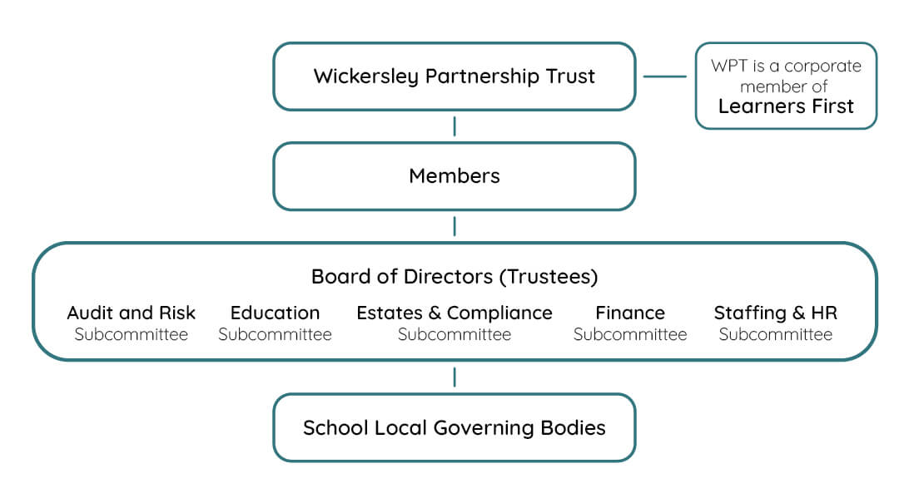

- Person Specification

The Directors set the overall strategic direction for the Academies collectively and are the people responsible under the Academy Trust’s articles of association for controlling its management and administration. They have responsibility for directing its affairs, and for ensuring that it is solvent, well-run, and delivering the Trust’s charitable outcomes for the benefit of the public. Although the Directors are directors of the company in company law terms, they are also charity trustees, as the Academy Trust is charitable in law.

To perform their role effectively, the Board of Directors must have a real understanding of the Trust’s structure, its aims and how it means to meet those aims. The recruitment and development of Directors is critical to good governance. The Trust aims to have an appropriately skilled and knowledgeable Board of Directors that collectively are able to provide strategic leadership and challenge Trust performance in the following key areas as a minimum:

- Student Welfare
- Teaching and Learning Pedagogic performance
- Human resources and staff professional development
- Asset management and operations
- Financial management

We are seeking two new Directors (Trustees) who will join the Audit and Risk and Finance subcommittees respectively. The skills and attributes we need for both roles include:

- Senior experience within a complex organisation in the public, private or not-for-profit sectors
- A strong interest in and commitment to education as well as an understanding of the governance arrangements of the education and charity sectors
- Demonstrably committed to the principles of equity, diversity and inclusion
- Collaborative approach to leadership and teamwork, with strong, interpersonal and relationship-building skills
- Intrinsically curious and probing while maintaining a balance of challenge and support
- Experience of successfully managing relationships in a complex, multi-stakeholder environment.

What we need for the Audit and Risk role:

- Understanding of audit and risk management within a complex environment.
- Good knowledge and experience of working in a senior finance role.
- Independence of mind: a proven track record of providing clear independent, balanced advice and guidance with the ability to challenge constructively.

What we need for the Finance role:

- An understanding of strategic finance including the ability to critically assess financial, performance and risk reporting
- Experience in non-Department for Education funding streams
- Commercial acumen and exposure, with experience of strategic financial development and management

- Additional Information

Time Commitment

There are eight Board meetings a year. The Audit and Risk Committee meets six times a year and the Finance Committee meets three times a year. We estimate the overall commitment to be one day per month.

Conflicts of Interest

All candidates will be asked to declare any conflicts of interest. This will be examined to see if an actual conflict exists.

Terms of Appointment

This post is for an initial term of up to three years, which may be extended for one further term of three years.

Location:

Trustee meetings are held in Rotheram. Trustees can join Board meetings remotely, but it is expected that you are able to join one or two meetings or events in person during the year.

Training and Ongoing Development

We provide a full induction to the work of the charity and the role of the trustee. We also provide the opportunity for trustees to attend training events.

Remuneration

The position is unpaid, although we reimburse travel costs and other direct reasonable expenses incurred.

- How to Apply

The recruitment process is being undertaken by Inclusive Boards on behalf of Wickersley Partnership Trust. If you wish to apply for this position, please supply the following by
23:59 on 05/05/2024.

- A detailed CV, setting out your career history, with responsibilities and achievements
- A cover letter (maximum two sides of A4) highlighting your suitability for the role for which you’re applying and how you meet the person specification. Please note that the cover letter is an important part of your application and will be assessed.
- Details of two professional referees together with a brief statement of their relationship to you and over what period of time they have known you. Referees will not be contacted without your prior consent

If you have further questions after reading this pack, please email
wickersley@inclusiveboards.co.uk or call 0207 267 8369.

Please visit www.inclusiveboards.co.uk/opportunities to apply online or send your CV and cover letter to wickersley@inclusiveboards.co.uk.

